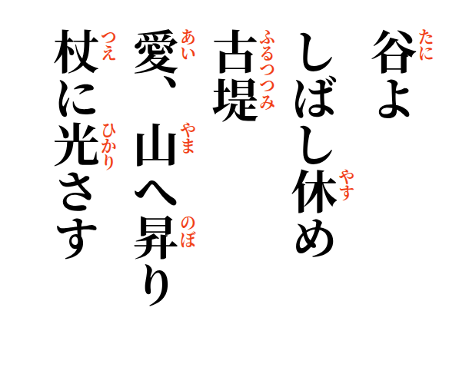

2026-08-27
Valley, rest a while—
the old dike remembers;
love rises into the mountains,
and light falls upon the cane.

